Research Title (16 Bold)

First Student Name¹, Second Student Name ¹, Third Student Name ¹(14)
¹(School, City, Country) (10 Italic)

Report will be printed on A4 paper (21.0 cm x 29.7 cm). The margins will be 3.0 cm left and 2.5 cm right, please take this into consideration.

Abstract (12 Bold): The abstract should summarize the content of the paper. It should include problem definition, solution approach, findings, and conclusions. It will be kept below 250 words. Do not use symbols, make references, nor display equations in the abstract. Your manuscript will be printed on A4 paper (21.0 cm x 29.7 cm). The margins will be 3.0 cm left and 2.5 cm right. Theme No.: Sub-Theme no. / Main Theme no. (12 Italic)
Keywords (12 Bold): Five key words in alphabetical order, separated by comma (12 Italic)

- INTRODUCTION (14 Bold and Caps letters)
The introduction of the paper should give definition to the problem, previous work and literature review, purpose, and the contribution of the paper. The contents of each section may be provided to understand easily about the paper. (12 single space)

- HEADINGS (14 Bold)
There will be a space before headings in the first level, and no space after. (12 single space)
  - Sub-Heading 1 (12 Bold)
  - Sub-Heading 2 (12 Bold)
There will be no space before or after headings in the second level. (12 single space)

Equations:
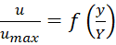 (1)
Tables:
Table (1): Prices of Materials (10 Bold)
No. | Item | Price
1 | Cement | 800 LE/ton

Figures:
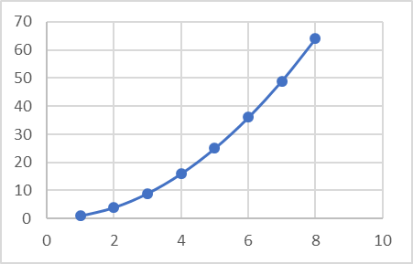
Figure (1): Variation of x with y

- CONCLUSIONS (14 Bold)
Conclusion section will be included and should indicate clearly the advantages, limitations, and possible applications of the paper. (12)

Acknowledgements (14 Bold)
An acknowledgement section may be presented after the conclusion section, if wanted. (12)

Symbols and Abbreviations (14 Bold)
a | Aspect ratio = b/Y | b | Channel bed width
C | Constant | D | Depth of Model
Fn | Froude Number | Rn | Reynolds Number
y | Channel depth

References (14 Bold)
Add references with definition numbers. These numbers are used to define the references wherever they are mentioned elsewhere in the paper.

